What is SDLC?

Software Testing Assignment
Module 1 - Fundamental

SDLC (Software Development Life Cycle) is a process used to develop software step-by-step. It includes planning, designing, coding, testing, and maintaining the software.

What is Software Testing?
Software Testing is the process of checking software to find errors or bugs and make sure it works correctly.

What is Agile Methodology?
Agile Methodology is a way to develop software in small parts with continuous testing and feedback.
It focuses on teamwork, flexibility, and quick delivery.

What is SRS?
SRS (Software Requirement Specification) is a document that explains what the software should do and its requirements.

What is OOPs?
OOPs (Object-Oriented Programming) is a programming method based on objects and classes.
It helps organize code using concepts like inheritance, encapsulation, polymorphism, and abstraction.

Write Basic Concepts of OOPs
Basic Concepts of OOPs:
Class → Blueprint to create objects. Object → Instance of a class.
Encapsulation → Wrapping data and methods together.
Inheritance → One class gets properties of another class. Polymorphism → Same method, different behavior.
Abstraction → Showing important details, hiding complexity.

What is Object?
Object is an instance of a class.
It represents a real-world thing and contains data and functions.

What is Class?
Class is a blueprint or template used to create objects. It defines data and functions for objects.

What is Encapsulation?
Encapsulation is the process of combining data and methods into one unit (class) and hiding internal details for security.

What is Inheritance?
Inheritance is a feature where one class gets properties and methods from another class. It helps reuse code.

What is Polymorphism?
Polymorphism means one method can have different forms or behaviors. Same function name, different actions.

Write SDLC Phases with Basic Introduction
  - Planning Phase:
Define project goals, scope, resources, timeline, and budget. Conduct feasibility study to determine if the project is viable.
  - Analysis Phase:
Gather detailed requirements from stakeholders. Create SRS document. Identify what the system should do.
  - Design Phase:
Create system architecture, database design, UI/UX design. Plan how the system will work technically.
  - Implementation Phase:
Write actual code based on design documents. Developers build the software using programming languages.
  - Testing Phase:
Test the software for bugs and errors. Ensure it meets requirements and works correctly.
  - Deployment Phase:

Release the software to users. Install and configure the system in the production environment.
  - Maintenance Phase:
Provide ongoing support, fix bugs, add new features, and update the software as needed.

Explain Phases of the Waterfall Model
The Waterfall Model is a linear and sequential approach where each phase must be completed before moving to the next. Like a waterfall, progress flows in one direction.
Phases:
  - Requirement Analysis:
Gather all requirements. Create detailed documentation of what needs to be built.
  - System Design:
Design system architecture, database, and interfaces based on requirements.
  - Implementation:
Write code and develop software modules.
  - Testing:
Test the complete system to find and fix defects.
  - Deployment:
Deploy the software to production environment.
  - Maintenance:
Support users and fix issues after deployment.

Write Phases of Spiral Model
The Spiral Model combines iterative development with systematic aspects of the waterfall model. It focuses on risk analysis and allows multiple iterations.
Four Main Phases (repeated in each spiral):
  - Planning (Identification):

Gather requirements, identify objectives, and define project scope.
  - Risk Analysis:
Identify potential risks and find solutions. Build prototypes to test feasibility.
  - Engineering (Development):
Design, code, and test the software based on risk analysis results.
  - Evaluation (Customer Review):
Get customer feedback and plan for the next iteration.

Write Agile Manifesto Principles
Agile Manifesto Principles:
Customer satisfaction through early delivery. Welcome changes in requirements.
Deliver working software frequently.
Teamwork between developers and customers. Simple design and continuous improvement.
Face-to-face communication is best.
Working software is main progress measure. Regular review and improvement.

Explain Working Methodology of Agile Model and Pros & Cons
Working Methodology:
  - Sprint Planning:
Team selects work items from backlog for the upcoming sprint (2-4 weeks).
  - Daily Stand-up:
Short daily meeting where team shares progress and challenges.
  - Development:
Team works on tasks, tests features, and collaborates continuously.
  - Sprint Review:
Demonstrate completed work to stakeholders and get feedback.
  - Sprint Retrospective:
Team reflects on what went well and what can be improved.

Pros (Advantages):
    - Faster delivery of working software
    - Easy to accommodate changes
    - Better collaboration between team and customer
    - Continuous feedback and improvement
    - Higher customer satisfaction
    - Early detection of issues Cons (Disadvantages):
    - Requires experienced team members
    - Less predictable timelines and costs
    - Documentation can be neglected
    - Requires active customer involvement
    - Not suitable for projects with fixed scope

Use Case Diagrams :-
- Draw Use Case Diagram - Online Bill Payment System (Paytm)

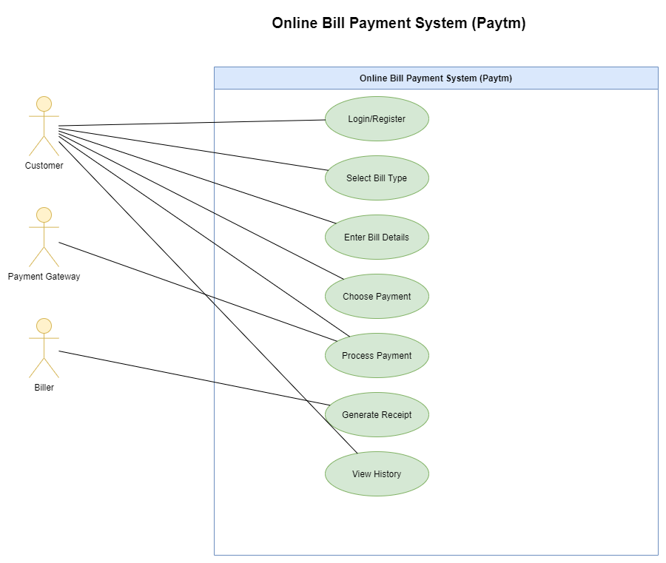

- Draw Use Case Diagram - Banking System for Customers

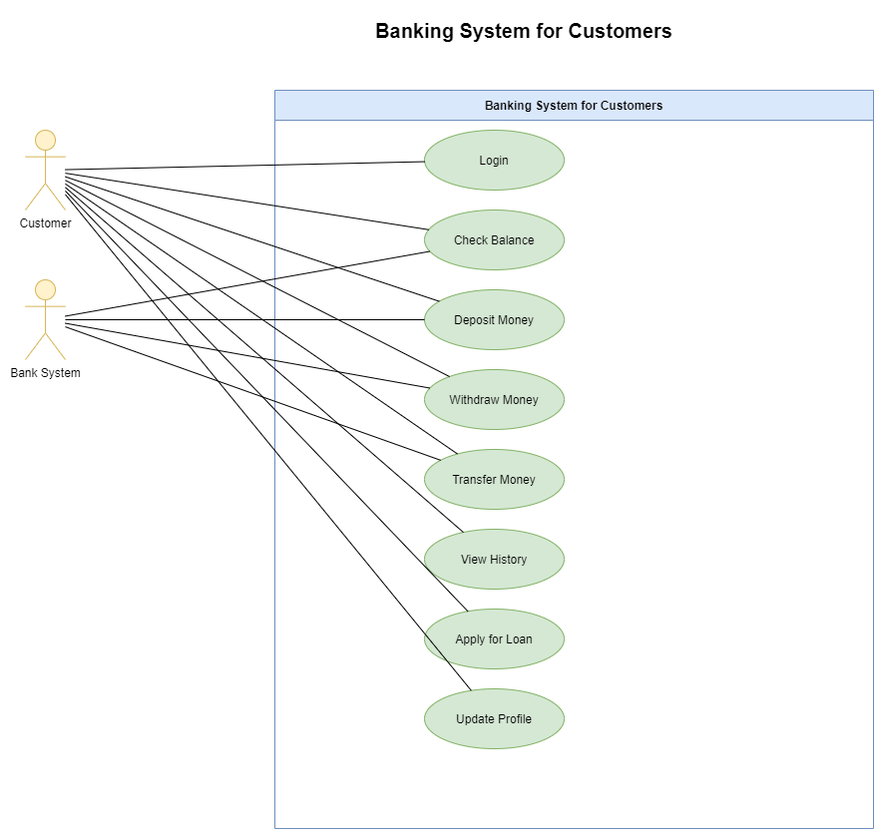

- Draw Use Case Diagram - Broadcasting System

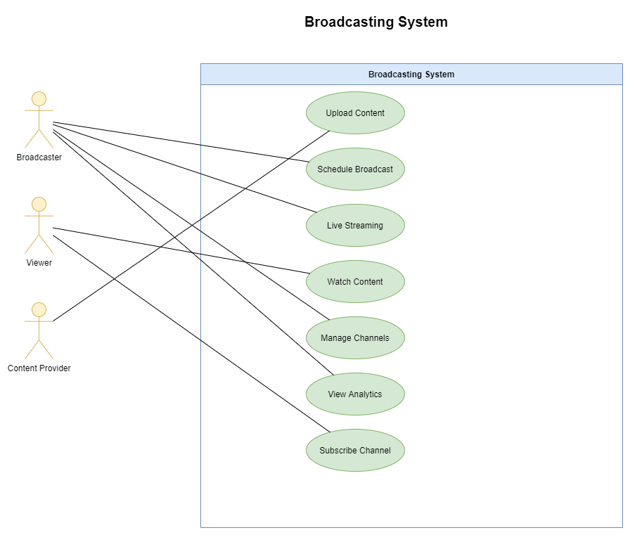

- Use Case Diagram - OTT Platform

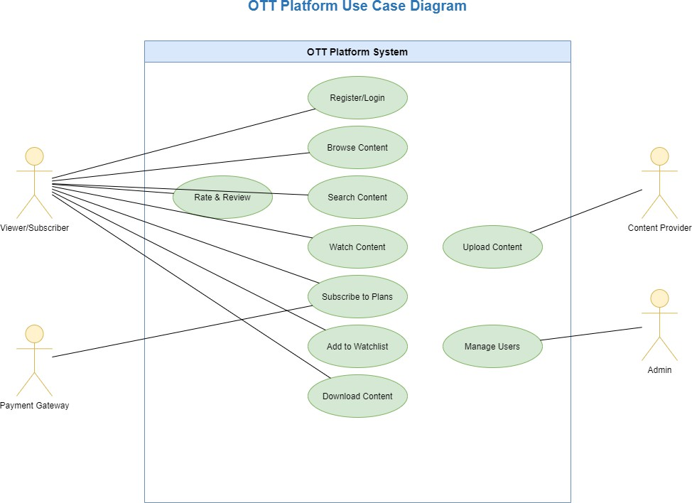

- Draw Use Case Diagram - E-commerce Application

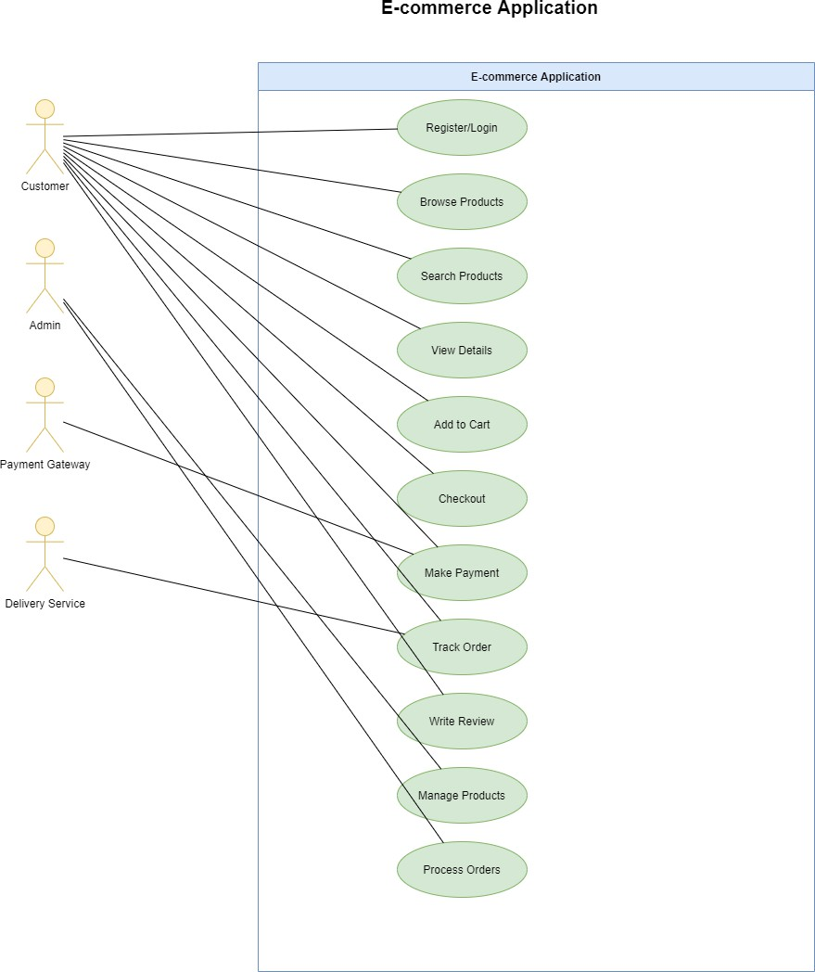

- Draw Use Case Diagram - Online Shopping Product Using Payment Gateway

